**Engineering**

**Faculty of**



**School of Electrical, Electronic & Computer Engineering**

**EERI 423**

**PRACTICAL ASSIGNMENT 2: Digital modulation schemes in the presence of noise**

Completed by:

**Mr J.P. de Lange 23689293**

Submitted to:

 **Prof A. Helberg**

05 June 2017

# DECLARATION

I, **Johannes de Lange**, declare that this report is a presentation of my own original work.

Whenever contributions of others are involved, every effort was made to indicate this clearly, with due reference to the literature.

No part of this work has been submitted in the past, or is being submitted, for a degree or examination at any other university or course.

Signed on this, 5th day of June 2017, in Potchefstroom.

J.P. de Lange

**INITIALS AND SURNAMES**

# TABLE OF CONTENTS

DECLARATION ii

TABLE OF CONTENTS iii

LIST OF FIGURES iv

LIST OF TABLES v

1. INTRODUCTION 1

1.1 BACKGROUND 1

1.2 LITERATURE REVIEW 1

2. SIMULATIONS AND RESULTS 3

2.1 8PSK MODULATION TECHNIQUE 3

2.1.1 No Hamming 3

2.1.2 Hamming 5

2.1.3 8PSK Hamming vs No Hamming 6

2.2 QAM-16 MODULATION TECHNIQUE 7

2.2.1 No Hamming 7

2.2.2 Hamming 9

2.2.3 QAM-16 Hamming vs No Hamming 9

3. VARIATIONS AND COMPARISONS 11

4. CONCLUSION AND RECOMMENDATIONS 13

References 14

# LIST OF FIGURES

Figure 1 : Schematic representation of a PSK8 modulator 1

Figure 2 : Example constellation for QAM-16 modulation 2

Figure 3 : Visual representation of Hamming code function 2

Figure 4 : 8PSK Modulation and demodulation scheme over an AWGN channel 3

Figure 5 : 8PSK original signal constellation diagram 4

Figure 6 : 8PSK signal constellation diagram with 10dB Eb/No 4

Figure 7 : 8PSK signal constellation diagram with 30dB Eb/No 5

Figure 8 : 8PSK Modulation and demodulation scheme over an AWGN channel with Hamming coding and decoding 5

Figure 9 : 8PSK theoretical plot vs simulated plot with and without Hamming 6

Figure 10 : QAM-16 Modulation and demodulation scheme over an AWGN channel 7

Figure 11 : QAM-16 original signal constellation diagram 7

Figure 12 : QAM-16 signal constellation diagram with 10dB Eb/No 8

Figure 13 : QAM-16 signal constellation diagram with 30dB Eb/No 8

Figure 14 : QAM-16 Modulation and demodulation scheme over an AWGN channel with Hamming encoding and decoding 9

Figure 15 : 8PSK theoretical plot vs simulated plot with and without Hamming 9

Figure 16 : 8PSK vs QAM-16 no Hamming comparisson 11

Figure 17 : Illustration of where 8PSK no Hamming signal has the same BER as QAM-16 with Hamming 12

# 

# LIST OF TABLES

Table 1 : List of Abbreviations v

Table 2 : Compared properties of the QAM-16 and 8PSK modulation schemes 11

Table : List of Abbreviations

|  |  |
| --- | --- |
| **Abbreviation or Symbol** | **Meaning** |
| 8PSK | Phase Shift Key 8-Bit |
| QAM-16 | Quadrature Amplitude Modulation 16-Bit |
| BER | Bit Error Rate |
| AWGN | Additive White Noise Generation |
| Eb/No | Signal to Noise |

## INTRODUCTION

### BACKGROUND

The differences between modulation schemes range depending on application, noise margins on the transmission medium between points, and even just the speed of data transmission.

In this practical we will compare the QAM-16 modulation scheme to that of PSK8, and also investigate the effects that Hamming coding would have on the bit error rates of the two different modulation schemes.

### LITERATURE REVIEW

#### 8PSK

8PSK (8 Phase Shift Keying) is a phase modulation algorithm.

Phase modulation is a flavour of frequency modulation where a carrier is modulated to encode digital information in phase changes. This scheme can encode 3 bits of data into each symbol. This allows a higher data rate at a relatively low cost.

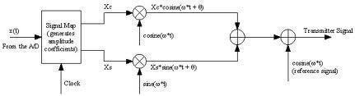

Figure : Schematic representation of a PSK8 modulator

#### QAM-16

QAM-16 is a digital amplitude modulation scheme in which digital information is encoded in bit sequences of 4-bit frames, these sequences are represented by several discrete amplitude levels of its analogue carrier signal. The signal constellation shown below illustrates the general configuration of these levels.

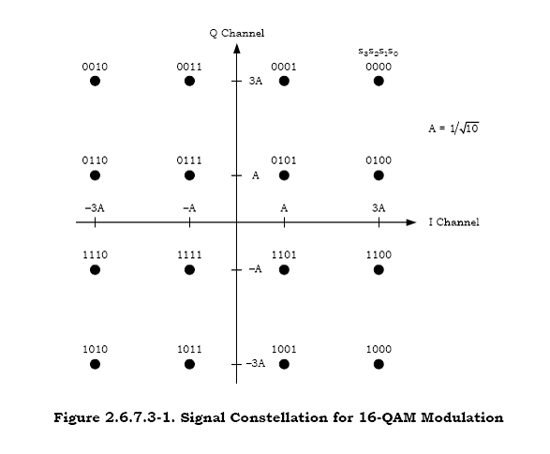

Figure : Example constellation for QAM-16 modulation

QAM employs both phase and amplitude modulation.

#### Hamming coding



Figure : Visual representation of Hamming code function

In the image above, the 3 large circles represent the parity check equations that define Hamming code, the 7 regions represent the 7 bits used in the codeword. An error occurs if there is not an even number of 1’s in each big circle, if there is a single error in the transmission it can be fixed by changing the bit in the appropriate region corresponding to the error.

## SIMULATIONS AND RESULTS

All the simulations required Simulink software, part of the MATLAB toolboxes, and the BER graphs were drawn using the ‘bertool’ function in MATLAB.

It is important to note that all communications channels require a transmitter (Tx), a receiver (Rx), and some form of transmission medium usually referred to as a channel. In these cases, we have added modulation to attempt the correct transfer of digital data over analogous transmission channel, and these are to be compared with their more effective Hamming coded compliments to determine the efficacy of these techniques.

### 2.1 8PSK MODULATION TECHNIQUE

### 2.1.1 No Hamming

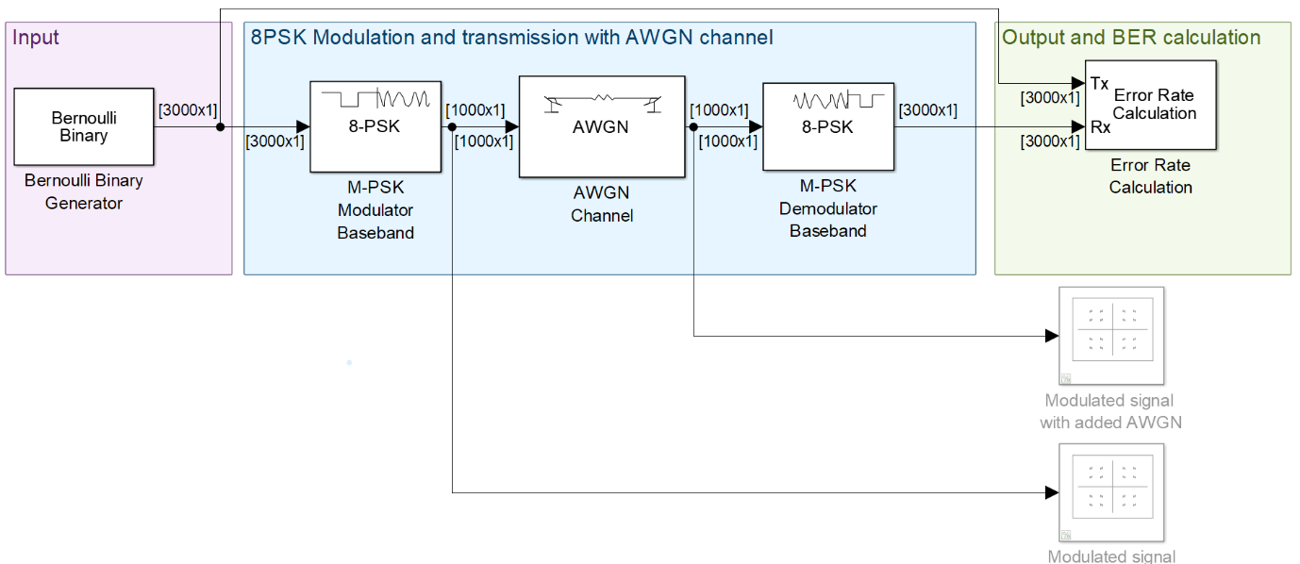

Figure : 8PSK Modulation and demodulation scheme over an AWGN channel

As seen above, the standard configuration was used to simulate the workings of an 8PSK transmission modulation over an AWGN channel, where the pre-modulation bits are compared to the post-demodulated bits to determine the amount of errors within a certain number of samples, while also specifying the Eb/No present in the AWGN channel.

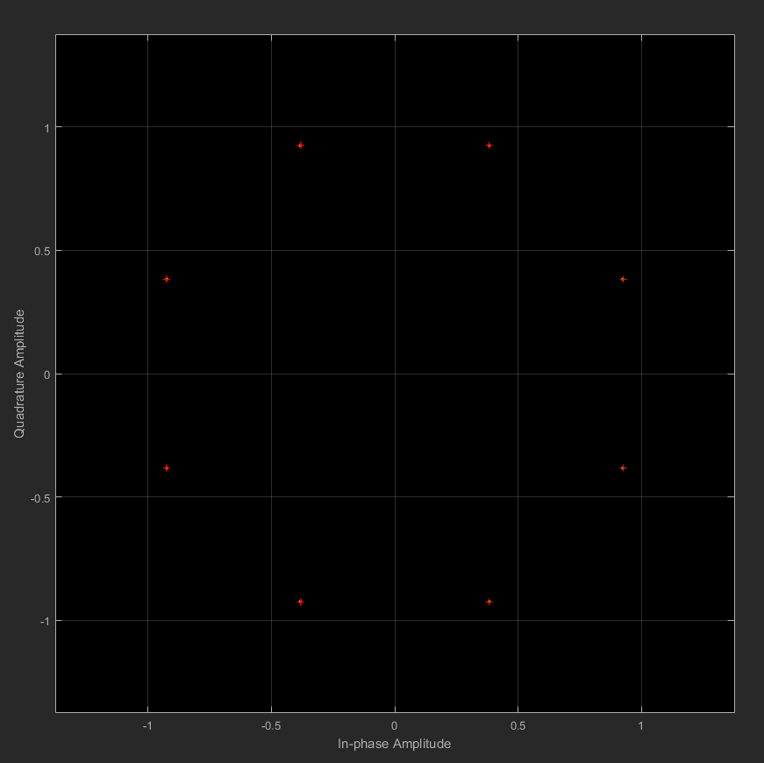

Figure : 8PSK original signal constellation diagram

Here we can see the modulated signal constellation diagram before the noisy channel is introduced. It is visible here that there are zero errors present at this stage as all the values fall exactly on the Gray-coded coordinate points.

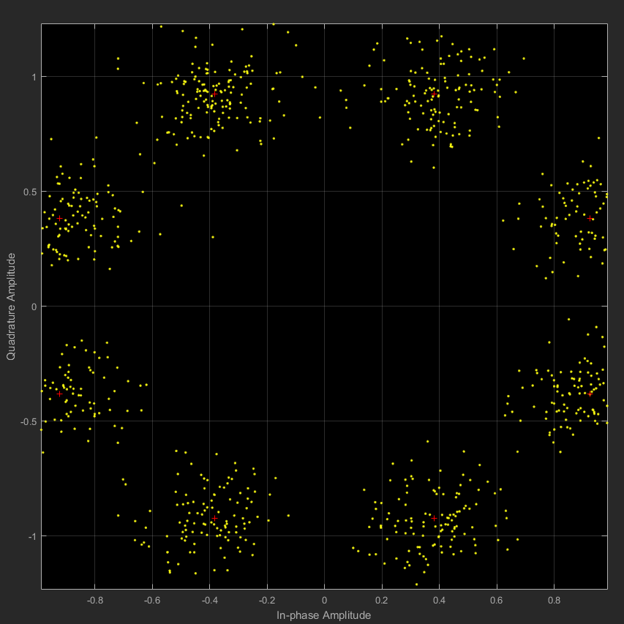

Figure : 8PSK signal constellation diagram with 10dB Eb/No

After a 10dB Eb/No is selected in the AWGN channel, it is visible that there is a very large spread of values, and this means the BER will be very large.

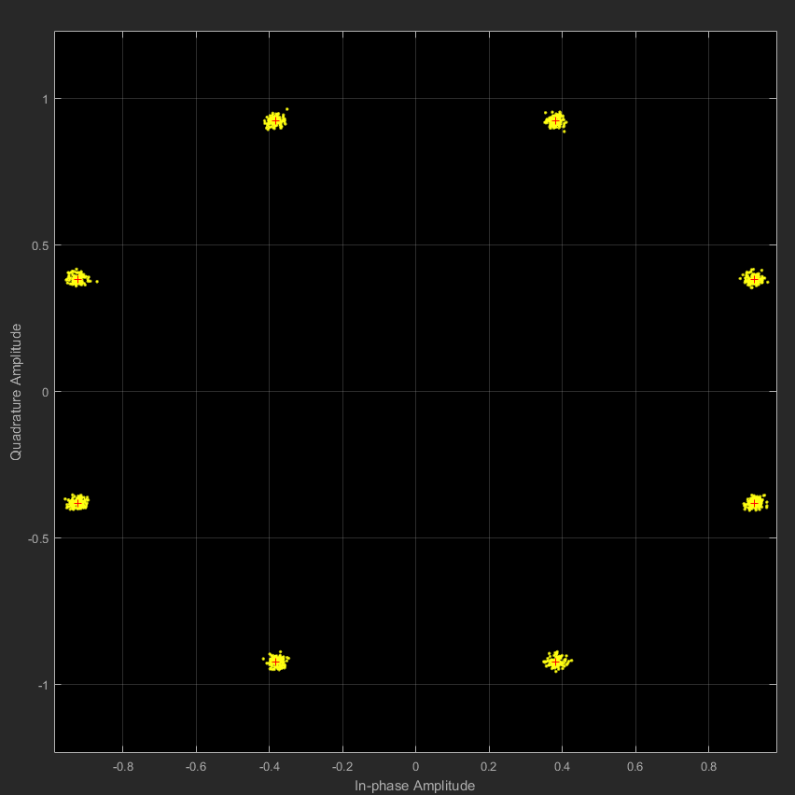

Figure : 8PSK signal constellation diagram with 30dB Eb/No

In contrast with the 10dB Eb/No, the 30dB version shows that the stronger signal to noise ratio yields a much smaller spread in values, and this means that the BER will be much smaller.

### 2.1.2 Hamming

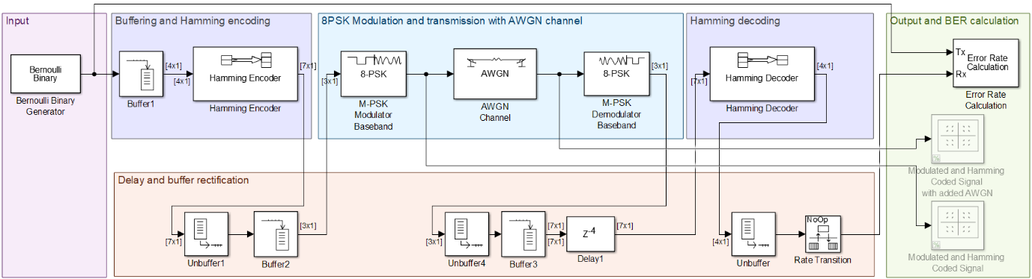

Figure : 8PSK Modulation and demodulation scheme over an AWGN channel with Hamming coding and decoding

In the diagram shown above, the complexity is clearly much higher than that of the scheme without Hamming encoding and decoding. The reason for this is that instead of bundling bits in frames of 3 for the 8PSK modulation scheme, they first have to be buffered into words of 4 bits before being encoded to a 7-bit frame with Hamming error correction, then they have to be de-buffered and re-buffered to 3-bit frames for modulation, after demodulation they will get un-buffered again, and rebuffered into a 7-bit frame for Hamming decoding before being delayed for a short while for the buffer to fill, from where the 4-bit decoded and error corrected frame will then be un-buffered the last time, the bit rate transitioned to match the original Tx signal rate, and then compared to determine the BER.

### 2.1.3 8PSK Hamming vs No Hamming

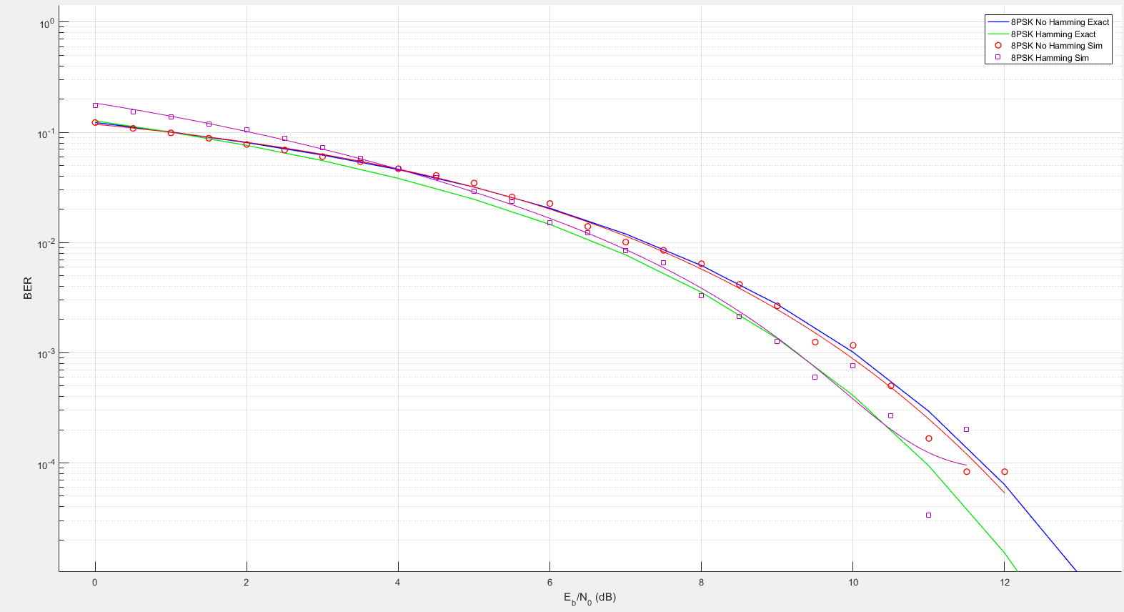

Figure : 8PSK theoretical plot vs simulated plot with and without Hamming

Here we can see a graphical representation of the BER at various levels of Eb/No, and the trends followed by the different techniques. The first set to be considered is the 8PSK modulated signal without Hamming through an AWGN channel. The exact theoretical plot (blue), is compared to the simulated result plots which were then fitted (red), and the correlation is almost perfect. The second set is the same signal that has been encoded for error detection and correction using the Hamming method. Again, the exact theoretical plot (green), is compared to the simulated and fitted version (magenta), and some deviance can be seen in the origin, but as the Eb/No of the channel increases toward 30dB the tendency of the simulated results converges with that of the theoretical values and produces an acceptable result. It is important to note that the BER for the Hamming scheme decreased more rapidly than that of the non-Hamming scheme. This outcome displays the fact that using Hamming error correction and detection decreases the amount of errors in transmission.

### 2.2 QAM-16 MODULATION TECHNIQUE

### 2.2.1 No Hamming

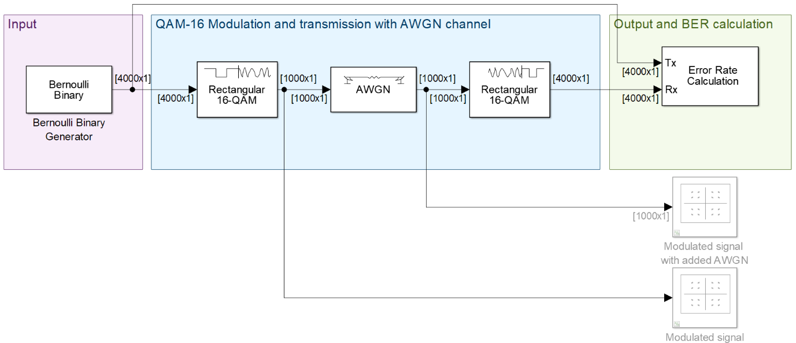

Figure : QAM-16 Modulation and demodulation scheme over an AWGN channel

For the QAM-16 scheme the same setup is used as for the 8PSK scheme, the only difference is that the modulation is now QAM-16 which requires a 4-bit frame instead of 3-bit frame. These frames are modulated in their 16 different Gray-coded binary configurations, and then get transmitted through an AWGN channel and are again demodulated.

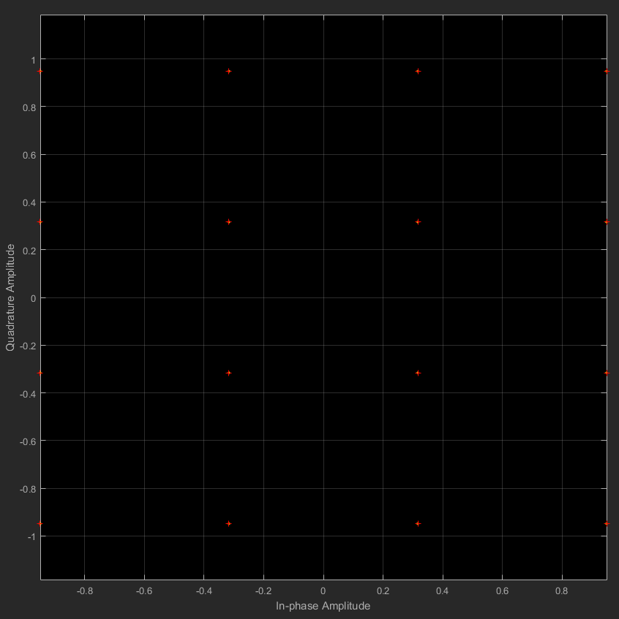

Figure : QAM-16 original signal constellation diagram

Figure 11 displays the original modulated signal and no deviation or spread is visible now, yet in Figure 12 below, the 10dB Eb/No shows a large spread of the plots which indicates that the AWGN channel has caused a large amount of interference and this will ultimately cause errors during demodulation presenting in a high number of errors per sample.

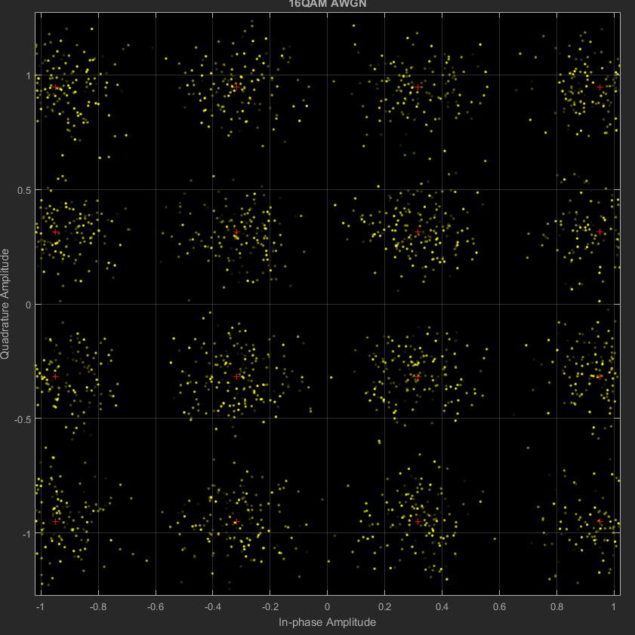

Figure : QAM-16 signal constellation diagram with 10dB Eb/No

Below in the 30dB Eb/No version of the AWGN channel, the spread of the plots is vastly reduced, and demodulation will present fewer errors. This case will again provide the lowest possible BER for a finite set of samples.

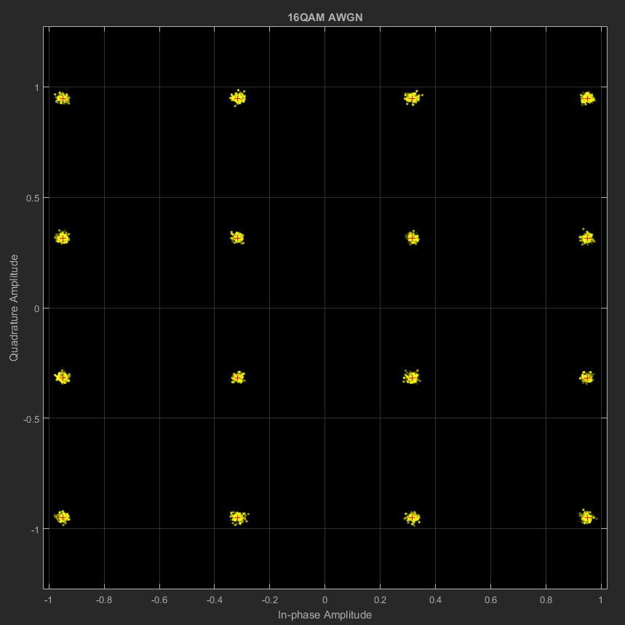

Figure : QAM-16 signal constellation diagram with 30dB Eb/No

### 2.2.2 Hamming

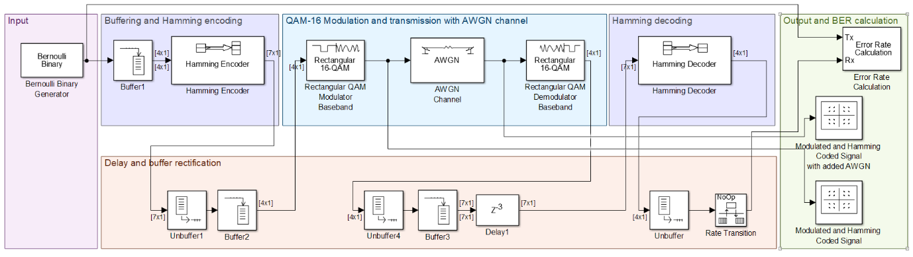

Figure : QAM-16 Modulation and demodulation scheme over an AWGN channel with Hamming encoding and decoding

The procedure in adding Hamming encoding is almost identical to that of the 8PSK scheme, lest for the 3-bit frames needed for modulation in 8PSK, the QAM-16 scheme requires 4-bit frames, and thus buffering and un-buffering will therefore vary slightly.

### 2.2.3 QAM-16 Hamming vs No Hamming

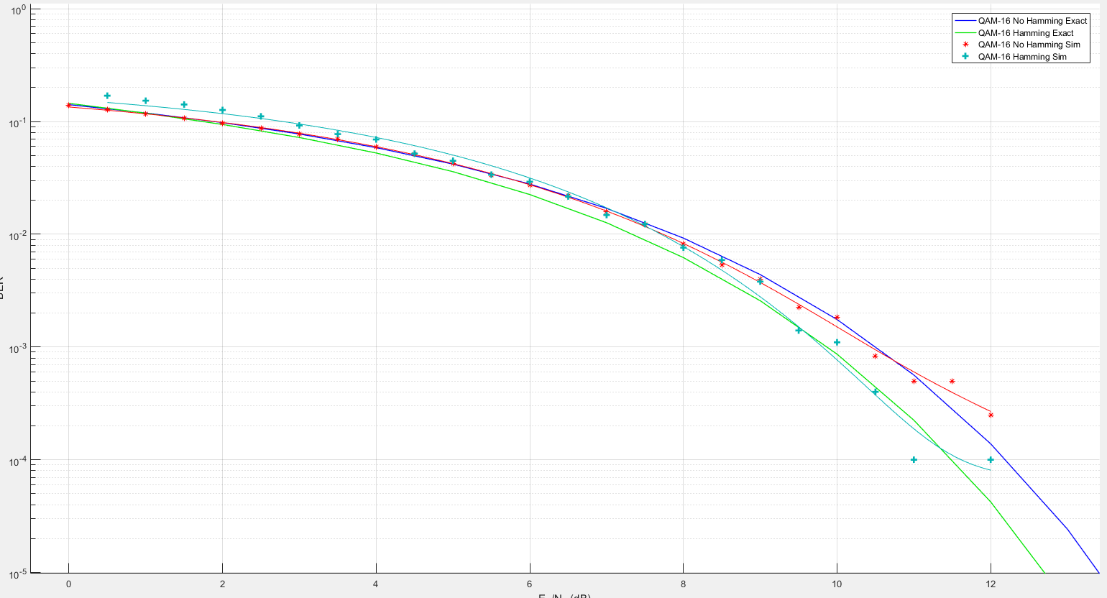

Figure : 8PSK theoretical plot vs simulated plot with and without Hamming

Figure 15 shows the comparison between the QAM-16 scheme with and without Hamming encoding, both theoretical exact values and simulated values will be discussed.

The non-Hamming scheme exact theoretical plot (blue), is compared with the simulated version (red), showing slight variation with strong correlation. The Hamming error detection and correction version of the scheme with exact theoretical plot (green), shows a lower amount of errors when compared to the non-Hamming version, and the simulated results for QAM-16 with Hamming (cyan), shows deviation at lower Eb/No, but tends to convergence as the Eb/No nears the 30dB value, and thus correlation is satisfactory.

## VARIATIONS AND COMPARISONS

Below in the table, the properties of the two different modulation schemes will be listed and then discussed.

Table : Compared properties of the QAM-16 and 8PSK modulation schemes

|  |  |  |
| --- | --- | --- |
|  | QAM-16 | 8PSK |
| Number of bits needed for modulation | 4 | 3 |
| Theoretical Coding gain at 1000 samples | 0.6dB | 0.4dB |
| Simulated Coding gain at 1000 samples | 0.74dB | 0.37dB |
| BER at 10dB Eb/No | 0.091 | 0.001 |

As seen in the table above the 8PSK modulation scheme maintains a much lower BER than the QAM-16 modulation scheme. This is mainly since errors are far more likely to occur when 16 different combinations of 4 bits are modulated, transmitted, and demodulated, than in the opposing 8 combinations from 3 bits. The Hamming coding gain experienced by the QAM-16 scheme is also greater than that of the 8PSK scheme, but this is mainly since a higher BER was present without coding.

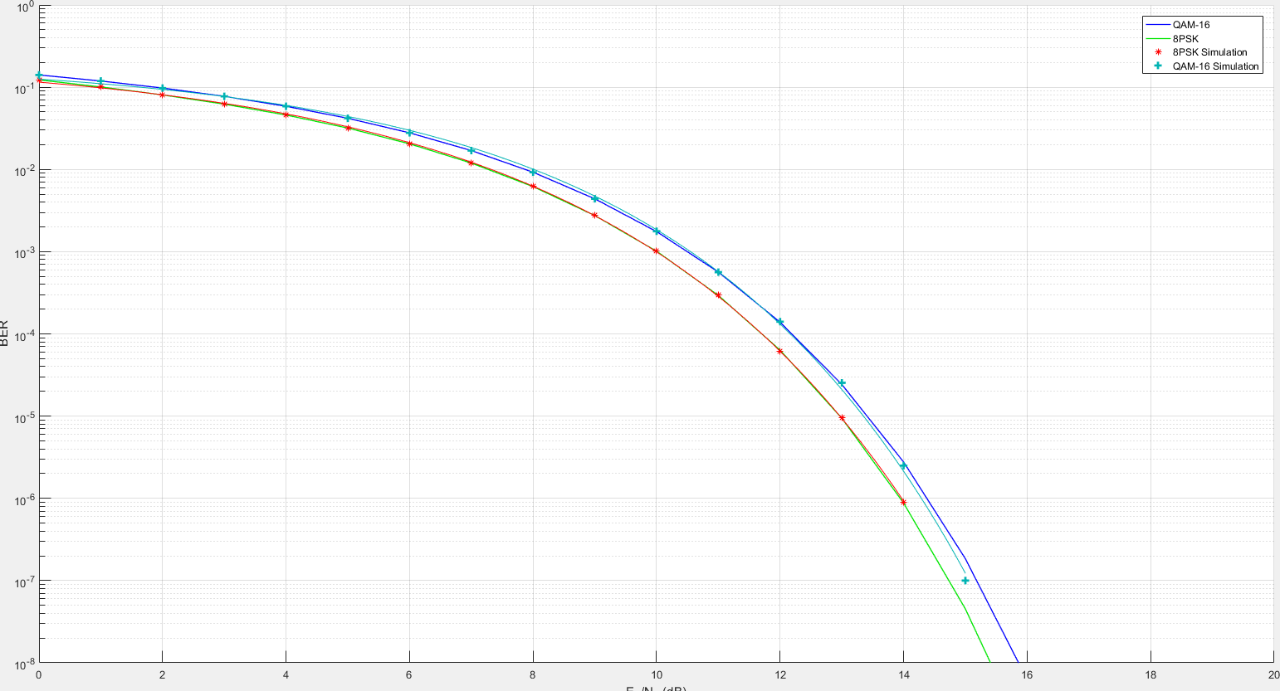

Figure : 8PSK vs QAM-16 no Hamming comparisson

In Figure 16 we can see the graphical illustration of the BER of the two different modulation schemes. QAM-16 (blue), is nonconvergent with 8PSK (green), and they will never have the exact same BER. This just illustrates once again that the QAM-16 modulation scheme will always be more susceptible to errors than the 8PSK counterpart.

In Figure 17 below, the point where QAM-16 modulation with Hamming error detection intersects with the 8PSK modulation is illustrated using the cursor in the MATLAB environment. The Eb/No point at which QAM-16 with Hamming becomes more effective than plain 8PSK without Hamming, is at about 8dB Eb/No.

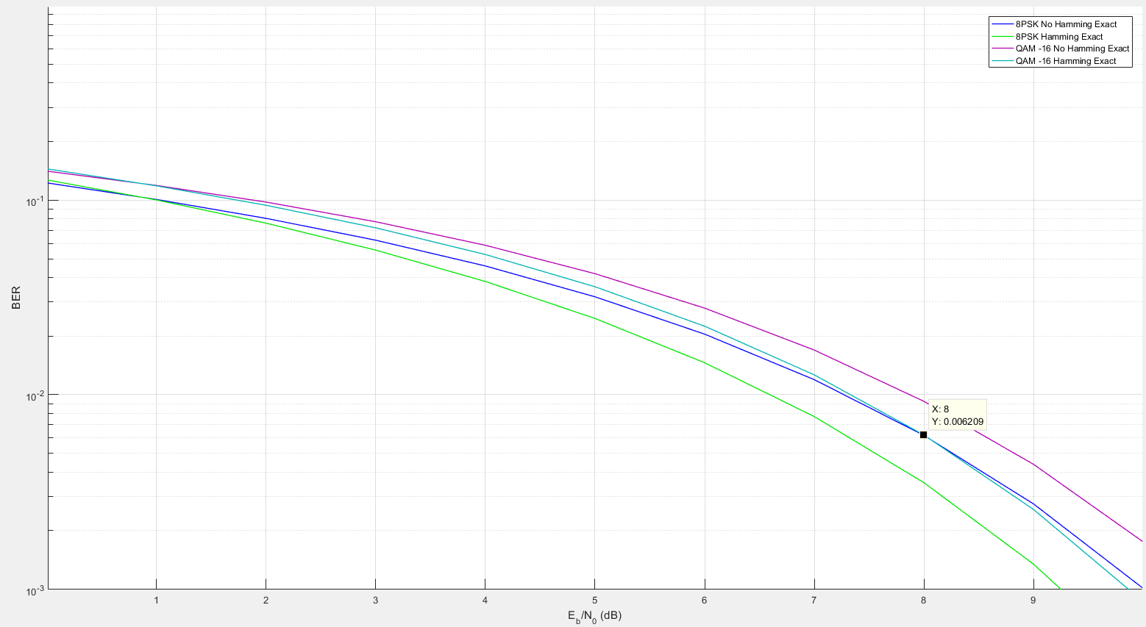

Figure : Illustration of where 8PSK no Hamming signal has the same BER as QAM-16 with Hamming

The benefits of Hamming code are in that it corrects 1 error automatically, and can detect for 2 more, it lowers the BER of the underlying modulation scheme quite drastically and improves the overall confidence level of the output signal.

The disadvantages of Hamming error correction are that below a certain number of samples per Eb/No the BER values become volatile, and they can even produce more errors should the synchronisation of the data rates not be matched properly. Hamming encoding also requires more processing power and more expensive equipment to implement.

## CONCLUSION AND RECOMMENDATIONS

In conclusion, we can state that 8PSK modulation suffers from fewer errors than QAM-16 modulation, yet has a lower data transfer rate. The addition of Hamming error detection encoding techniques will make QAM-16 more effective than 8PSK without Hamming, but only in moderately noisy to noiseless transmission mediums with an Eb/No higher than 8dB.

The results obtained from all the simulations produced satisfactory results, showing the correlation of the effects of noise on the transmission medium, and that the BER can be lowered using Hamming coding techniques.

# References

|  |  |
| --- | --- |
| [1] | "8PSK", *Tech-faq.com*, 2017. [Online]. Available: http://www.tech-faq.com/8psk.html. [Accessed: 06- Jun- 2017]. |
| [2] | H. Belloc, *On*. Freeport, N.Y.: Books for Libraries Press, 1967. |
| [3] | D. Humphrys, "Hamming Code (1 bit error correction)", *Computing.dcu.ie*, 2017. [Online]. Available: http://www.computing.dcu.ie/~humphrys/Notes/Networks/data.hamming.html. [Accessed: 06- Jun- 2017]. |